Fill in the equipment ID as a free text entry. Be sure to type it in exactly as it is on the equipment. If known, please also denote the equipment manufacturer.

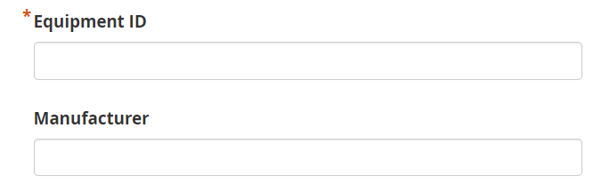

Please select the facility that the equipment will reside in from the options provided.

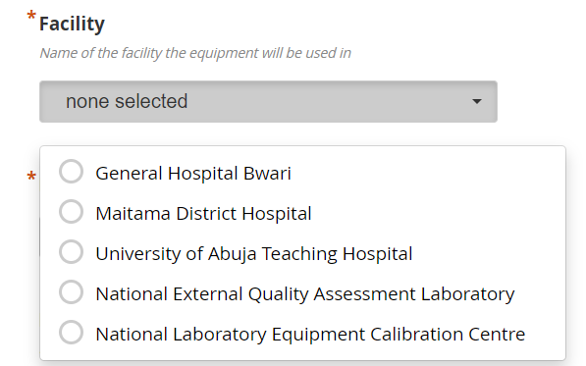

Select the equipment type from the option provided. If the options do not accurately describe a given piece of equipment, choose ‘Other’ and then denote the equipment type in the next question.

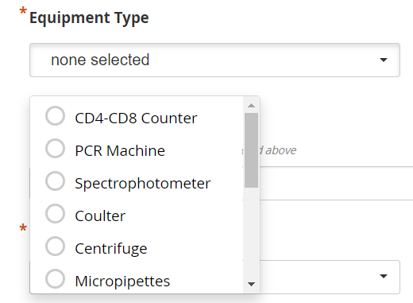

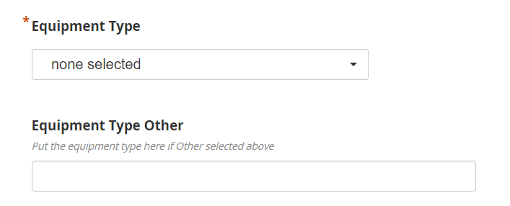

Select the lab level of the lab the equipment will reside in. While the options provided should be sufficient, if the lab level of a piece of equipment is not provided, choose ‘Other’ and provide the level in the next question.

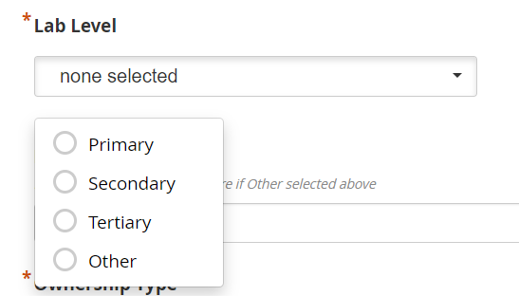

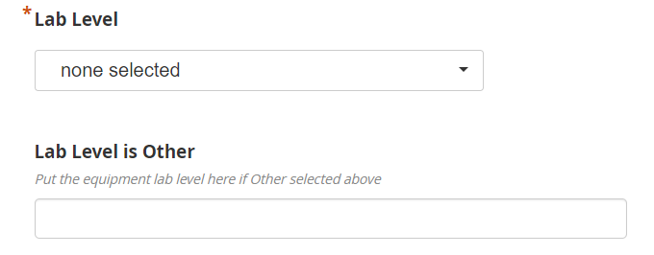

Choose the funder who procured the equipment. While this can be difficult to define, choose the best possible response. If the choices are not sufficient, choose ‘Other’ and provide a response in the next question.

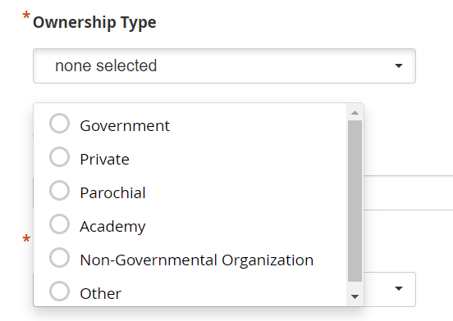

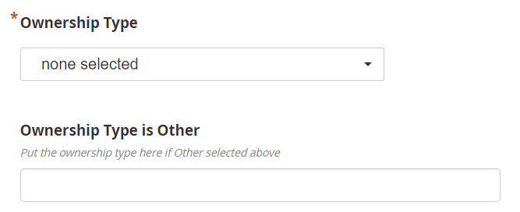

Denote whether the piece of equipment is still under warranty.

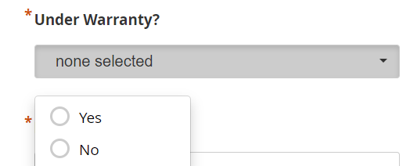

Denote whether the piece of equipment is functional in its current state. If it will be fixed in the future but is currently non-functional, please denote it as such.

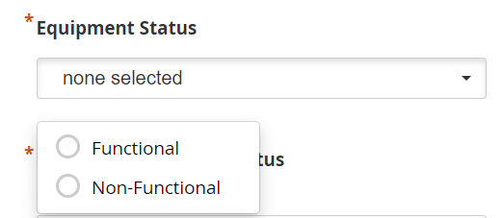

Denote whether the piece of equipment was purchased using the lab’s budget or donated.

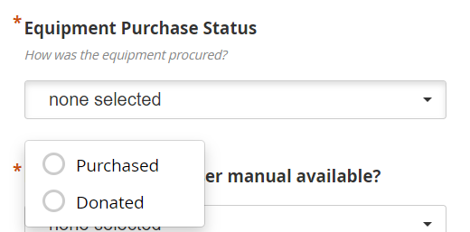

Denote whether the equipment user manual is available. Denote ‘Yes’ if either the paper manual that came with the equipment is on hand or an online equivalent can be found.

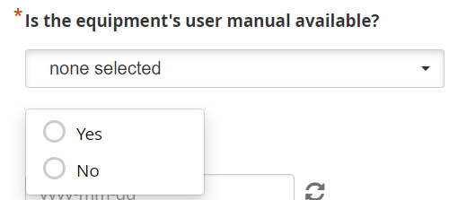

If known, denote the date the piece of equipment was manufactured.

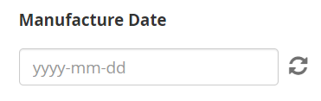

Denote in days, how often the equipment should either be maintained or calibrated. If there is no clear maintenance or calibration schedule, enter ‘0.’

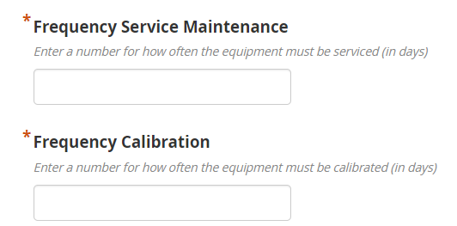

Denote the date the equipment first became active in the lab. If this is unknown put the current date.

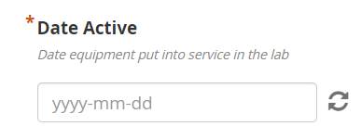

Enter the service provider name (person or company) as well as their email address.

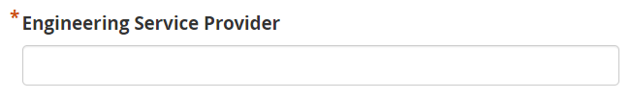

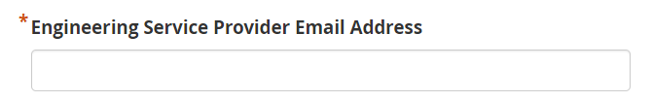

If known enter the last date of calibration or maintenance. Leave blank if the equipment is new.

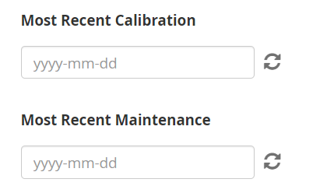

If known enter the coordinates of the lab that the equipment will reside in. If coordinates are unknown you can search for the city or address in the map provided on the right that will populate the estimated coordinates.

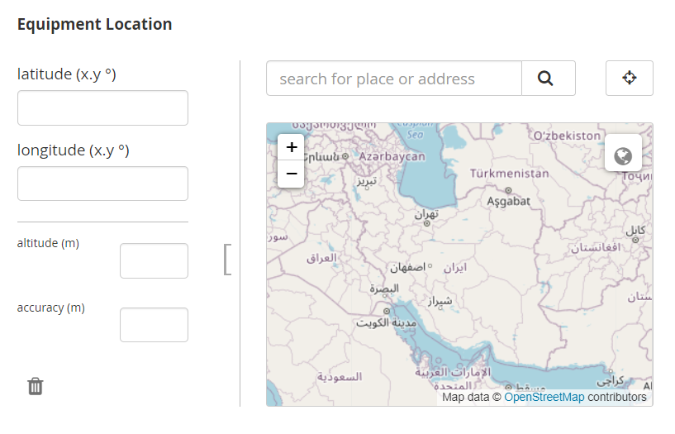

Lastly, enter any challenges in filling out this survey as well as suggestions as to how we might improve this registration form.

